MRMv2 RPE Reports

MRMv2 RPE Reports 1
Introduction 1
Listings & Profiles 1
Report Template Details 2
Executing Reports 4

Introduction
The MRMv2 comes with 6 standard report templates that show the type of reports that can be created using Rational Publishing Engine (RPE). The RPE can create reports based on data that is stored in RequisitePro and Rational Requirements Composer(RRC). RRC also contains out of the box reports that use the RPE engine. This document will describe the custom reports created for the MRMv2 using data stored in RequisitePro. For details on how to use RPE, please see the online user manuals located at: http://publib.boulder.ibm.com/infocenter/rsdp/v1r0m0/index.jsp?topic=/com.ibm.help.download.tpe.doc/topics/publishingengine_version1_1.html.

Listings & Profiles
There are two types of report templates provided - listings and profiles. Listings provide a listing of one type of business component and its relationship with another type of business component. Profiles provide details of one type of business component and relationships to numerous types of business components.
The following 4 listing report templates are provided:
- Organization Units and Programs listing (PGOUListing.dta) – This reports lists all Organization Units. For each Orgnaization Unit, all “Accountable” Programs are listed.
- Programs and Services listing (PGSVListing.dta) - This report lists all Programs and related Services.
- Services and Processes listing (SVPRListing.dta) – This report lists all Services and related Processes.
- Process and Resources listing (PRREListing.dta) – This report lists all Processes and related Resources.
The following 2 profile reports templates are available:
- Service Profile (ServiceProfile.dta) – The Service Profile report lists all Services within a jurisdiction. For each Service, its attributes are displayed along with all related Outputs, Change Drivers, Performance Indicators, Organization Units and Programs.
- Program Profile (ProgramProfile.dta) – The Program Profile report lists all Programs within a jurisdiction. For each Program, its attributes are displayed along with all related Outcomes, Change Drivers, Performance Indicators, Organization Units and Services.

Report Template Details
All reports created for the MRMv2 follow a similar pattern and therefore only one will be examined in detail – The Services Profile.
The Services Profile template (ServiceProfile.dta) contains 6 data source schemas. Each data source is responsible for describing a specific data structure stored in RequisitePro.

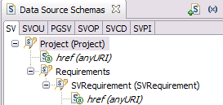
Figure 1 – Data Source Schemas
The 6 data source schemas SV, SVOU, PGSV, SVOP, SVCD, SVPI are based on the MRMv2 meta model structure that is reflected in RequisitePro and therefore have been given names to reflect this. As such, the SV data source schema contains the structure of a Service, the SVOU contains the structure of a Service Accountabilities (Service / Organization Unit relationship entity) and so on.

Figure 2 shows the top portion of the Service Profile report template. This template is constructed with a number of report palette objects but mostly it is made up of containers within containers.
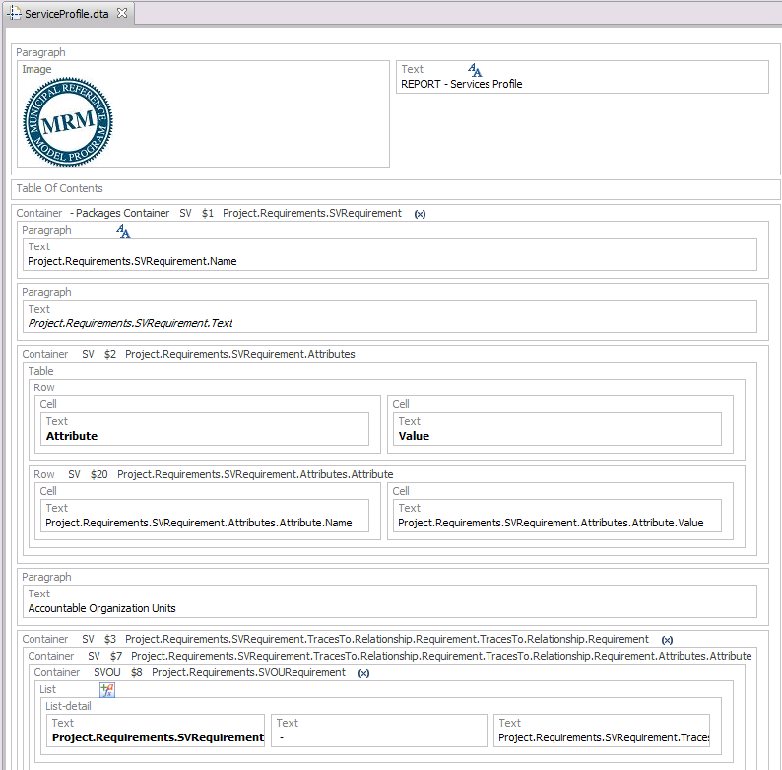
Figure 2. Service Profile report template

At the top of this report template, shown in Figure 2, is a paragraph containing an image and text object. The image contains the MRM logo and the text contains a simple title for this report. Also notice there is a style applied to the title text. Following this paragraph is a Table of Contents object. This is a neat feature in RPE that generates a table of contents based on the content below it. After the table of contents is where the meat of this report begins.
The first and outermost container of this report template is a query which loops through all Services contained within the RequisitePro project. It uses the SV data source schema and goes after the SVRequirement which represents a Service instance in RequisitePro. The image means there is a variable assignment on this object. To view the variable assignment
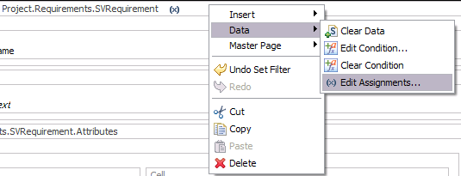
Figure 3. Variable Assignment

right click on the container and go to Data->Edit Assignments as shown in Figure 3. Doing so will reveal that a variable ServiceName has been set to the Name of the Service Instance. The first two objects within this container are a paragraphs which contain text objects. These are used to display the Service instance name and description.
The next object within the Service parent container is a table which is used to display the attributes of the Service instance. This is shown in figure 4.

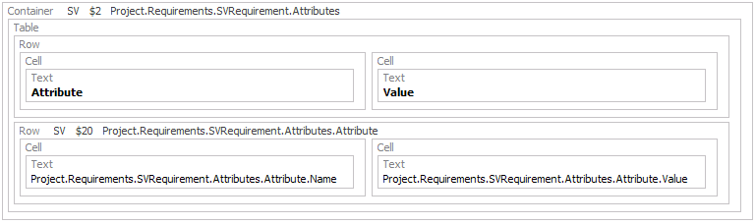
Figure 4. Attributes table
This container contains a query on the attributes for the Service instance. A Table object is contained within the container and it has two rows. The first row simply contains text for the titles of the colums. The second row queries each attribute in the attributes list of a Service and then displays the attributes Name and Value.
The next container within the report is shown in Figure 5. It contains the accountable organization units related to the Service instance. Each container after this one follows a similar pattern only this one will be explained in detail.

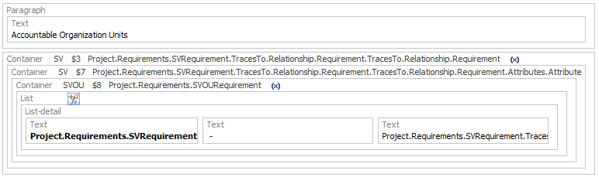
Figure 5. Accountable Organization Units

The first object in the container is a paragraph containing a text object which holds a title for the organization units. The properties view of this text object is shown in Figure 6. It reveals that the text will be underlined.
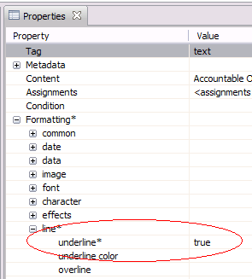
Figure 6. Properties view of text object

Following the paragraph containing the “Accountable Organization Units” text we see there are a number of containers embedded within one another (Figure 5). The top most container contains a query of all the entities that are two relationships away and trace to the Service instance. Lets explain: Having a look at the MRMv2 meta model we see that a Service maps to Service Accountabilities and then to Organization unit, see Figure 7.
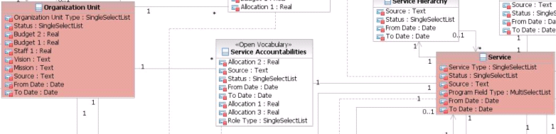
Figure 7. MRM Meta Model
The code for Service Accountabilities is SVOU. This is used in RequisitePro as the Prefix but also tells us the direction of navigation. Services map to Organization Units through RequisitePro’s “trace to” feature. It doesn’t mean that an Organization Unit cannot see its Services. This could be accomplished using the “trace from” feature in RequisitePro. An example of this is shown in the next section of the Report when we list the Programs associated with each Service. In that example the code for Program Services (entity relating programs and services in meta model) is PGSV. Therefore, you’ll notice we use the trace from capability in the query when going after Programs.
There could possibly be other entities that are two relationships away from a Service instance (ie. Change drivers, Performance Indicators, etc.) so a filter is required on the data being retrieved. Looking at the properties view of this top most container we see there is a filter applied, see Figure 8.
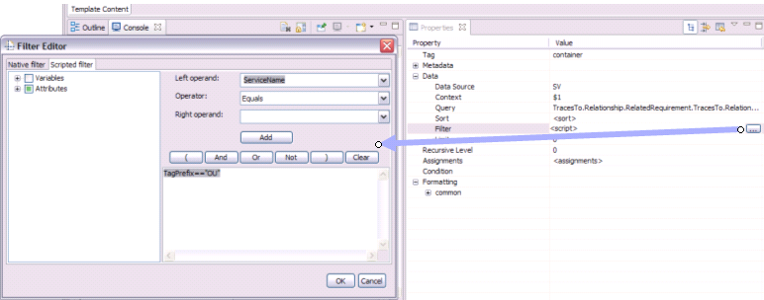
Figure 8. Filter for Organization Units
The filter shows that only instances that contain the TagPrefix == “OU” should be returned. There is also a variable be set on this container which is evident by the symbol on the container. To see the assignment, right click on this top most container (Figure 5) and select Data -> Edit Assignments. The variable OrgUnitName is assigned to the name of the Organization Unit returned from the query. This variable will be used in a lower container. Moving to the next container shown in Figure 9,
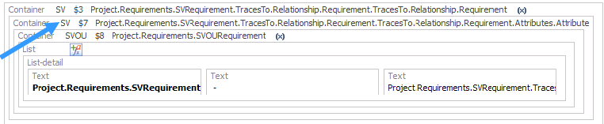
Figure 9. Attribute Query
this query is used to further filter the list of Organization Units that are returned. Analyzing the filter on this container shows that we only want records where the attribute “Deprecated” is not equal to “true”. Deprecated is an attribute used on all meta model components and relationships to mark something as deleted without physically deleting it. Therefore, we definitely don’t want deleted items showing up in our reports.
The next embedded container returns all Service Accountability records. We need these records in order to check the Role Type equals “Accountable” and also to make sure these relationships are not Deprecated. Analyzing the filter on this container will show exactly that, only return records where RoleType == “Accountable” and !(Deprecated==”True”). The reason we don’t check Deprecated==”false” is that Deprecated could be false or not set which is also false. So, to make sure we capture both cases we stick to checking that it’s not true. There is also variables being set on this container. Opening the Edit Assignments reveals two variables being set, SVOUServiceName and SVOUOrgUnitName. Having a look at the assignments of these variables shows how we use JavaScript to extract the values we desire. The names of all relationships in MRMv2 follow the following construct – “BusinessComponentFrom_BusinessComoponentTo”. Knowing that Services point to Organization Units (SVOU) we know that the Service Name is contained before the “_” and the Organization Unit name is after the “_”.
The next report object is a List that contains one List-detail and three Text objects. On the List object is a condition denoted by the graphic. Right clicking on the List Object and selecting Data -> Edit Condition reveals the condition that must be true in order for the Text within the List Detail to appear. The condition shown in Figure 10 shows that ServiceName==SVOUServiceName && OrgUnitName==SVOUOrgUnitName
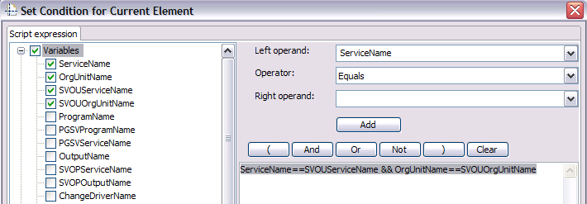
Figure 10. List Detail Condition
The following condition ensures that we display the correct Organization Unit below the Service Instance.

Executing Reports
A sample output of this report can be seen in Figure 11 and Figure 12 (This report is based on a test data).
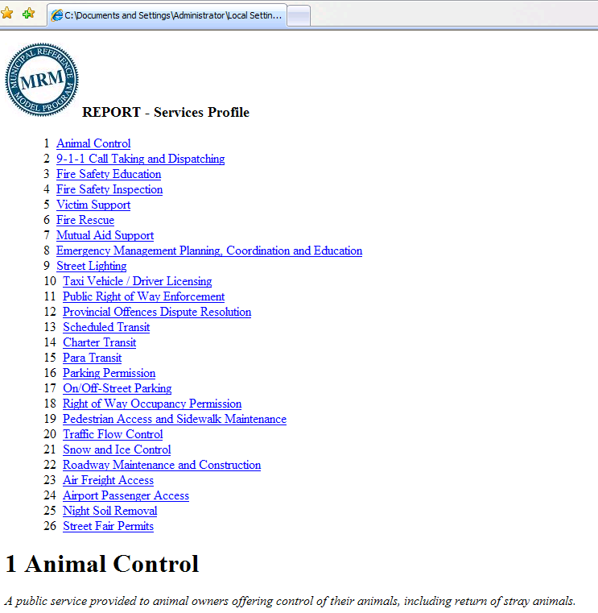
Figure 11. Table of Contents
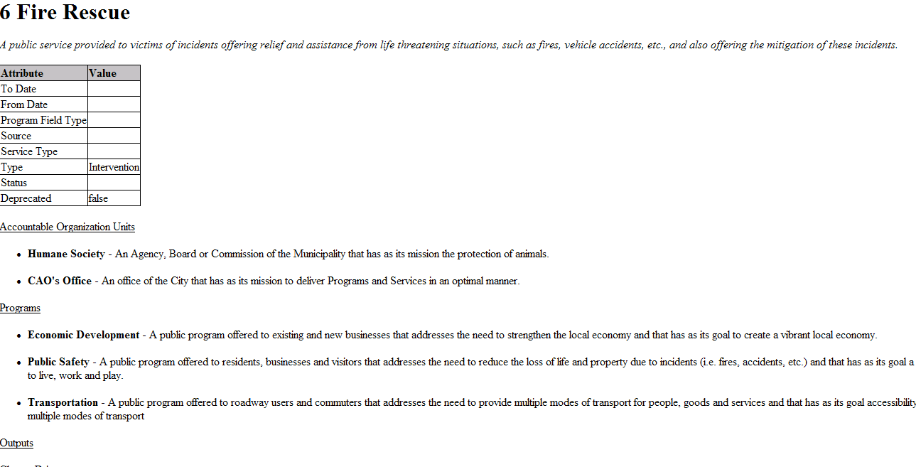
Figure 12. Fire Rescue Service and associated Comonents
To execute a report template one must create a report specification. An example of a report specification for the ServiceProfile.dta is shown in Figure 13. This shows the Services Profile report being executed against a fictitious Gotham City jurisdiction.
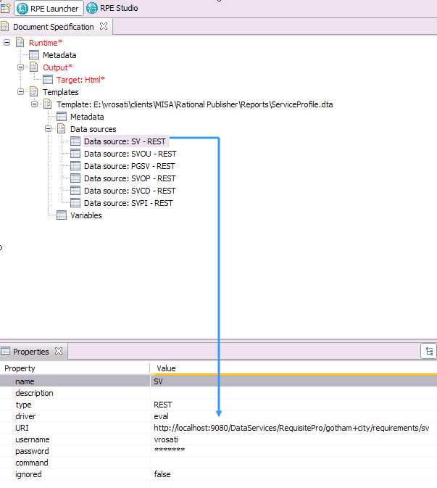
Figure 13. Document Specification
Each of the data sources in the report template are realized in the specification with actual sources of data. Figure 13 shows how the SV data source is pointing to the http://localhost:9080/DataServices/RequisitePro/gotham+city/requirements/sv url and requires a username and password (username and password for the RequisitePro project being reported on). All data sources share the http://localhost:9080/DataServices/RequisitePro/gotham+city/requirements/ path with only the end differing depending on the entity required. The Output shown in Figure 13 contains Target: Html which means only an html report is generated. If you desire an MS Word doc or PDF simply add the desired output.
From the RPE menu, selecting Document Specification->Generate Current Document will execute the report as shown in Figure 14.

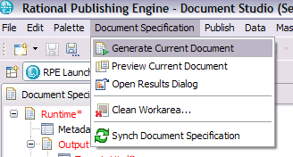
Figure 14. Generating the report

